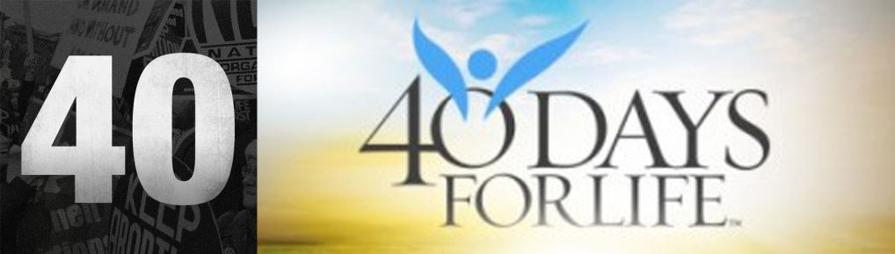

Bulletin/Newspaper Announcement
for your 40 Days for Life Campaign’s
40 Film Screening event
(to be customized with your event information)

40 Days for Life (XXX) presents
a FREE screening of the "40" film
DAY, MONTH, DATE
TIME
PLACE
ADDRESS
QUESTIONS & RSVP: XXX
The "40" film presents abortion as the most important human rights issue of our time! The movie features over 40 national pro-life leaders. Also featured are inspiring stories and deeply personal interviews addressing some of the strongest arguments for the pro-choice/abortion position countered by pro-life answers. The movie is directed by John Morales, producer of the award winning film "Champions of Faith: Baseball Edition." John is also a former Fox sportscaster. The movie is free of charge. The movie is family friendly, with content suitable for ages 14 and up.
Can incorporate poster.jpeg or 40.jpeg: Download here

